Software Engineering Group Project

Using Git hub for windows

|  |  |
| --- | --- |
| Author: | Phil Wilkinson |
| Config Ref: | SE_N02_GH_01 |
| Date: | 07-12-2012 |
| Version: | 1.1 |
| Status: | Draft |

Department of Computer Science

Aberystwyth University

Aberystwyth

Ceredigion

SY23 3DB

Copyright © Aberystwyth University 2012

CONTENTS

CONTENTS 2

1. Introduction 3

1.1 Purpose of this Document 3

1.2 Scope 3

1.3 Objectives 3

2. Acquring GitHub for Windows 3

3. Obtaining the repository files 4

4. Committing/Syncing 5

REFERENCES 5

DOCUMENT HISTORY 6

# Introduction

## Purpose of this Document

Provide users of group number 2 of the Software Engineering Group Project 2012 with a basic understanding of how to use github for windows, with the remote git repository system on ‘github.com’.

## Scope

All members committing to GitHub.com and using GitHub for windows should read this document if they are not clear on how to use it.

## Objectives

The objective of this document is to allow users of group number 2 of the Software Engineering Group Project 2012 the ability to commit and sync their local github directory with github’s remote directory.

# Acquring GitHub for Windows

There are two main methods of obtaining GitHub for Windows:

* Google ‘GitHub for Windows’
* Visit [**windows**.**github**.com](http://windows.github.com/)

After this, you will need to install it. Don’t think I need to explain how to install an .exe to fellow CompSci students.

# Obtaining the repository files

You will need to obtain read/write permissions to access and change the private repository (repo). In the case of this project, you will need to contact ‘Dave Haenze’ who hosts the repo. You will know that you have been granted access when a ‘page not found’ error is not displayed. You can see the screenshot below that the user has been given ‘Read+Write access’.

How GitHub works, is that you will need to “clone” the entire repository to your computer (local storage). The easiest way to do this is to actually go to the repo on github.com, and click the ‘Clone in Windows’ button. This link should open with your install of ‘GitHub for Windows’ and clone the repo to your local storage, whilst linking your local storage with the remote storage (on github.com). The local storage should be located in your ‘Documents/GitHub/’ directory. This is where you add/delete/modify the files you wish to commit and sync.

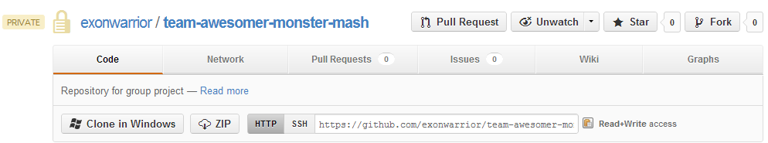

For this project, the repo is located at: <https://github.com/exonwarrior/team-awesomer-monster-mash>

It should look similar to this if the repo has been cloned correctly. To get to the commits, click on the arrow pointing to the right above the ‘open this repo’ popup grey box.

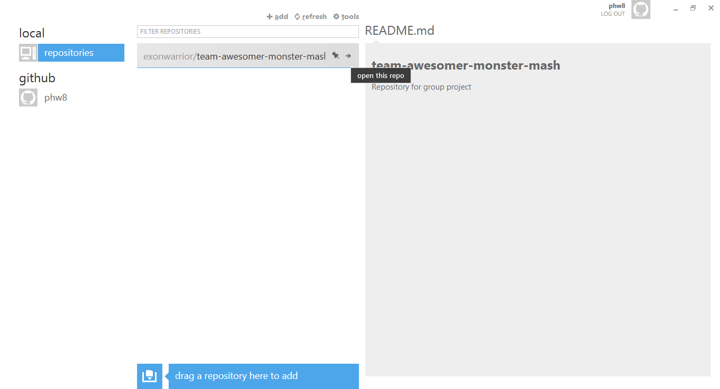

# Committing/Syncing

So in regard to committing, each ‘commit’ is like a snapshot of all changes that has been made since the last commit has been made. One can therefore look at the differences between two commits to see what has changed within the files. All the commits happen locally, and then are all “sync”-ed to GitHub.com via ‘GitHub for Windows’. ‘GitHub for Windows’ will detect any changes in the local repo folder on your computer ( ‘Documents/GitHub/[repo name]’)

As you’ve added the group repo to the program, you’ll want to make sure it’s sync-ed. It is a good idea to keep it sync-ed before committing in case other members have edited files that you’re working on too (plus check for new files).

If you change anything within the stated directory, then GitHub will detect this, and the ‘uncommitted changes’ yellow box will show (seen in the screenshot below). As stated, you will need to give a preferable concise statement of your commit for the ‘commit message’, and any more in-depth details for the ‘extended description’. Once you ‘commit’, the commit snapshot will be saved locally. You can do as many commits as you need to before syncing with the remote storage on GitHub.com.

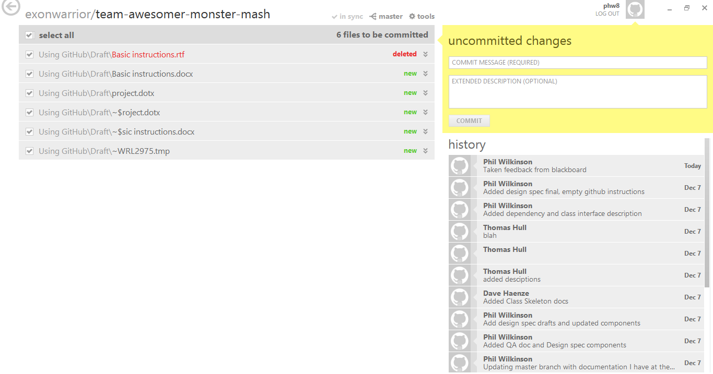

Once you have finished committing for the time-being, you can press the “sync” button (which replaces the “in sync” button when you have local commits needing pushing), to push the local commits to the remote storage on GitHub.com.

You should now know how to commit and push files to GitHub!

REFERENCES

N/A

DOCUMENT HISTORY

| *Version* | *CCF No.* | *Date* | *Changes made to document* | *Changed by* |
| --- | --- | --- | --- | --- |
| 1.0 |  | 07/12/2012 | Document created, initial write-up produced | PW |
| 1.1 |  | 07/12/2012 | Fixed spelling errors | PW |
|  |  |  |  |  |
|  |  |  |  |  |
|  |  |  |  |  |
|  |  |  |  |  |
|  |  |  |  |  |
|  |  |  |  |  |
|  |  |  |  |  |
|  |  |  |  |  |
|  |  |  |  |  |